|  |  |  |  |  |  |  |  |  |  |
| --- | --- | --- | --- | --- | --- | --- | --- | --- | --- |
|  | | | | | | | | | |
|  | Report on Lab-05  DATABASE MANAGEMENT SYSTEMS LAB | | | | | |  | |
|  |  | | | | | | |  | | |
| Submitted by  Adid-Al-Mahamud Shazid  Student Id: 210042172  Department: CSE  Programme: SWE  Course Title: CSE 4308  Submitted to  Zannatun Naim Sristy  Lecturer, Department of CSE  September 14, 2023 | |  | | | | |
|  |
|  | | |  |
|  | |  | | | |  | | | |

**Introduction**

In this lab class, we were given tasks based on advanced data manipulation techniques to solve using SQL command line to understand the basics of data definition and data manipulation. The given .sql file named banking.sql was executed before doing the following tasks.

**Task**

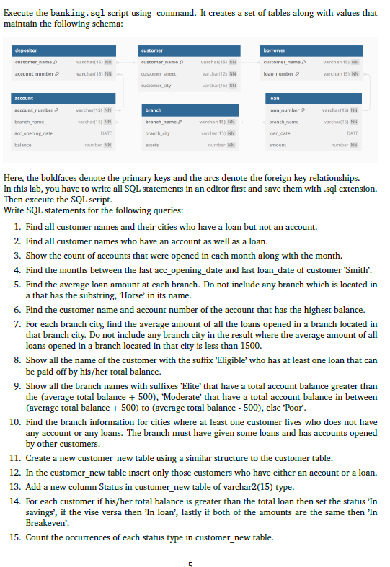

**Solution**

--Task 01--

select customer.customer_name, customer.customer_city

from customer, borrower

where customer.customer_name=borrower.customer_name

minus

select customer.customer_name, customer.customer_city

from customer, depositor

where customer.customer_name=depositor.customer_name;

--Task 02--

select depositor.customer_name

from customer, depositor

where customer.customer_name=depositor.customer_name

intersect

select borrower.customer_name

from borrower, customer

where customer.customer_name=borrower.customer_name;

--Task 03--

select extract (month from acc_opening_date)as months,count(*) as count

from account

group by extract (month from acc_opening_date);

--Task 04--

select months_between

(

    (select max(account.acc_opening_date)

    from depositor, account

    where depositor.account_number=account.account_number

    and depositor.customer_name= 'Smith'),

    (select max(loan.loan_date)

    from borrower, loan

    where borrower.loan_number=loan.loan_number

    and borrower.customer_name= 'Smith')

)month from dual;

--Task 05--

select a.branch_name, a.avg_amount from

(select branch_name, avg(amount) as avg_amount from loan group by branch_name) a,

branch where branch.branch_name=a.branch_name and

branch.branch_city not like '%HORSE%';

--Task 06--

select customer_name,account_number from depositor

where account_number in

(

    select account_number from account

    where balance=(select max(balance) from account)

);

--Task 07--

select branch_city,avg(amount) from loan,branch

where loan.branch_name=branch.branch_name

group by branch_city

having avg(amount)>1500;

--Task 08--

select customer_name||' '||'ELIGIBLE'

as customer_name from depositor

where account_number in

(

    select account_number from account

    where balance>=

    (

        select sum(amount) from loan

        where loan.branch_name=account.branch_name

        and loan.loan_number in

        (

            select loan_number from borrower

            where borrower.customer_name=depositor.customer_name

        )

    )

);

--Task 09--

select branch_name || ' Elite' as branch_name from branch

where branch_name in

(

    select branch_name from account

    group by branch_name

    having sum(balance) >

    (

        select avg(sum_balance) + 500 from

        (

            select branch_name, sum(balance) as sum_balance from account

            group by branch_name

        )

    )

)

union

select branch_name || ' Moderate' as branch_name from branch

where branch_name in

(

    select branch_name from account

    group by branch_name

    having sum(balance) between

    (

        select avg(sum_balance) + 500 from

        (

            select branch_name, sum(balance) as sum_balance from account

            group by branch_name

        )

    )

    and

    (

        select avg(sum_balance) - 500 from

        (

            select branch_name, sum(balance) as sum_balance from account

            group by branch_name

        )

    )

)

union

select branch_name || ' Poor' as branch_name from branch

where branch_name in

(

    select branch_name from account

    group by branch_name

    having sum(balance) <

    (

        select avg(sum_balance) - 500 from

        (

            select branch_name, sum(balance) as sum_balance from account

            group by branch_name

        )

    )

);

--Task 10--

select branch_name, branch_city from branch

where branch_city in

(

    select customer_city from customer

    where customer_city not in

    (

        select customer_city from customer

        where customer_name in

        (

            select customer_name from depositor

        )

        or

        customer_name in

        (

            select customer_name from borrower

        )

    )

)

and branch_name in

(

    select branch_name from loan

    group by branch_name

    having count(*) > 0

)

and branch_name in

(

    select branch_name from account

    group by branch_name

    having count(*) > 0

);

--Task 11--

create table customer_new as

select * from customer

where customer_name='SPOON';

--Task 12--

insert into customer_new

select * from customer

where customer_name in

(

    select customer_name from depositor

)

or

customer_name in

(

    select customer_name from borrower

);

--Task 13--

alter table customer_new

add status varchar2(15);

**Analysis and Explanation**

From this task I learnt some new functionalities and using sub queries properly.

**Difficulties**

I faced a few difficulties during several tasks.